

**Masters Project Final Report**

**December 2015**

|  |  |  |  |  |
| --- | --- | --- | --- | --- |
| **Project Title** | User Stress Detection through Emotion Understanding | | | |
| **Student Name** | Mudiyanselage Mayura Prakash Wijeyaratne | | | |
| **Registration No.**  **& Index No.** | 2012/MCS/068  12440681 | | | |
| **Supervisor’s Name** | Mr. D.A.S Atukorale | | | |
| **Please Circle the appropriate** | **Master’s Program** | | **Type** | |
| **MIT** | **MCS** | **Research** | **Implementation** |

|  |
| --- |
| **For Office Use ONLY** |
|  |
|  |

User Stress Detection through Emotion Understanding

**M. Mayura Prakash Wijeyaratne**

**2016**

## 

User Stress Detection through Emotion Understanding

**A dissertation submitted for the Degree of Master of Computer Science**

**M. Mayura Prakash Wijeyaratne**

**University of Colombo School of Computing**

**2016**



DECLARATION

The thesis is my original work and has not been submitted previously for a degree at this or any other university/institute.

To the best of my knowledge it does not contain any material published or written by another person, except as acknowledged in the text.

Student Name: Mudiyanselage Mayura Prakash Wijeyaratne

Registration Number: 2012MCS068

Index Number: 12440681

_____________________

Signature: Date: 30/12/2015

This is to certify that this thesis is based on the work of

Mr. Mudiyanselage Mayura Prakash Wijeyaratne

under my supervision. The thesis has been prepared according to the format stipulated and is of acceptable standard.

Certified by:

Supervisor Name: Mr. D.A.S. Atukorale

_____________________

Signature: Date: 30/12/2015

ABSTRACT

Deadline! Is the one word that every employee dreads of hearing, In the modern day where deadlines are in abundance, employees are asked to work harder than every before. Stress is body’s way of reacting to emergency situations and it also keeps your body alert to threats. Been in this state for a long period of time can be harmful to the human body and that should be avoided at all costs. Therefore, this research concentrate on the users of an IT company where they work for long periods of time in front of the computer, having tight deadlines to work with.

This research will primarily focus on getting physiological data in an non-invasive manner. In this research a webcam will be used to capture video feed of users working in front of the computer and extract still images, find the facial feature points of the user, converting them in to facial features, using them find the emotion of the user. As the data from the videos are unlabelled data, a popular algorithm for unsupervised learning, K-means algorithm is used to cluster the video frames to similar facial expressions.

Along the way different types of pre-processing methods will be explored to find the optimal result which could be achieved. The results of the system does give an indication of user being under stress.

This topic could be taken further with wearable devices coming to market like the Smart watch where users heartbeat could also be measure in non-invasive manner.

ACKNOWLEDGEMENTS

I’d like to express my sincere gratitude to everyone who helped in this lengthy endeavour.

I’d first like to thank my supervisor Dr. Ajantha Atukorale for being there to help and guide me through this unknown territory of a research area. He was the force behind this achievement, helping my in every way despite his busy schedule.

I’d like to thank my parents for helping me guiding me in doing this research. A special thanks goes to my brother and sister-in-law for the many hours of sacrifice of their own time to make this research project up to a good standard.

My thanks goes to my office colleagues for helping me in collecting the data that is needed to start this research and all my fellow MCS friends for their support.

Last but certainly not the least my girl friend for her encouraging words and motivation to continue this project at the hardest of times.

Thank you!

## TABLE OF CONTENTS

DECLARATION ii

ABSTRACT iii

ACKNOWLEDGEMENTS iv

LIST OF FIGURES vii

LIST OF TABLES viii

ABBREVIATIONS i

CHAPTER 1: INTRODUCTION 1

1.1. Motivation 2

1.2. Problem Statement 2

1.3. Aims and Objectives 3

1.4. Scope and Limitations 3

1.5. Expected Contribution 4

Summary 4

CHAPTER 2: BACKGROUND 5

Summary 6

CHAPTER 3: METHODOLOGY 7

3.1. Prototype architecture 7

3.2. Algorithms used to calculate facial features from facial feature points 8

3.3. Machine learning techniques for human emotion identification 13

Summary 14

CHAPTER 4: IMPLEMENTATION 15

4.1. Selection of the coding languages and libraries 15

4.2. Collection of videos to create a dataset 17

4.3. Creating a software application to extract feature points 19

4.4. Pre-processing of facial feature values 22

4.5. Training K-means clustering model 23

Summary 24

CHAPTER 5: EVALUATION & RESULTS 25

5.1. Discussion on the feedback from users participated for data collection 25

5.2. Discussion on the results of K-means clustering 26

5.2. Results of different pre-processing methods 31

Summary 32

CHAPTER 6: CONCLUSION & FUTURE WORK 33

6.1. Retrospect on the aims and objectives 33

6.2. Conclusion derived from the results 33

6.3. Future work 34

REFERENCES 35

APPENDIX 1 : Facial feature calculation mathematical formula in python I

1.1. Implementation of the mathematical formulae I

1.2. Calculate the value for each feature IV

APPENDIX 2 : Feedback forms V

LIST OF FIGURES

Figure 3.1: Prototype architecture of the system 7

Figure 3.2: Facial feature points [7] 8

Equation 3.1: Gradient of eyebrows 9

Equation 3.2: Distance between eyebrows and eyes ( f2 ) 9

Equation 3.3: Normalisation factor 9

Equation 3.4: Area between eyebrows ( f3 ) 10

Equation 3.5: Area of eyes ( f4 ) 10

Equation 3.6: Vertical to horizontal ratio of eyes ( f5 ) 10

Equation 3.7: Area of the circumference of a mouth ( f6 ) 11

Equation 3.8: Area of inner circumference of a mouth ( f7 ) 11

Equation 3.9: Vertical to horizontal ratio of the circumference of a mouth ( f8 ) 11

Equation 3.10: Vertical to horizontal ratio of the inner circumference of a mouth ( f9 ) 12

Equation 3.11: Vertical position of the corner of a mouth ( f10 ) 12

Figure 4.1: Video capture application 18

Figure 4.2: Output image from Luxand API 20

Figure 4.3: Luxand API not detecting the face 20

Figure 5.1: Feedback form questions 25

Figure 5.2: Image which shows happy emotion (Frame #994) 27

Figure 5.3: Another image which shows a happy emotion (Frame #99) 27

Figure 5.4: Happy emotion in test data (Frame #2515) 28

Figure 5.5: Happy emotion in test data (Frame #2121) 29

Figure 5.6 : Face with a neutral emotion in test data 30

Figure 5.7: Face with a neutral emotion in test data 30

LIST OF TABLES

Table 5.1: Frame count at each stage 26

Table 5.2 : K-means clustering labelling of video frames using Min-Max Analysis 31

Table 5.3: K-means clustering labelling of video frames using Z-Score Analysis 31

ABBREVIATIONS

HRV Heart Rate Variability

BVP Blood Volume Pulse

PD Variations of Pupil Diameter

GSR Galvanic Skin Response

ECG Electrocardiogram

SVM Support Vector Machine

LDA Linear Discriminant Analysis

FACS Facial Action Coding System

CHAPTER 1: INTRODUCTION

Deadline! This is the one word every employee dreads of hearing. In the modern day where deadlines are inabundance, it has made employees work harder than ever before. Richard Boyatzis, Ph.D. has shown through Neuroimaging that deadlines often limit thinking, can lead to worse decision-making and can increase stress levels [1]. “Stress isn’t always bad, though. Stress within your comfort zone can help you perform under pressure, motivate you to do your best, even keep you safe when danger looms. But when stress becomes overwhelming, it can damage your health, mood, relationships, and quality of life” [2].

What is stress?

Stress is body’s way of responding to any threat by releasing stress hormones, including adrenaline to arouse to make an emergency reaction. This is also called “fight or flight”, this helps you to stay focused energetic and alert [2].

Why do we need stress at a certain level and why is it harmful if it you allow it to overwhelm you?

While, in emergency situations stress can save your life, however having stress all the time and more than your comfort zone will actually be detrimental to your mind and body [2]. Heart disease, sleep problems, depression, weight problems are some harmful effects of having stress for a long period of time at a level than a person can handle. "Over time, if you're constantly in fight-or-flight, if your heart muscles and valves are awash in the epinephrine, it causes changes in the arteries and in the way that cells are able to regenerate,” [3]. Due to the above-mentioned reasons, it is very important for people to maintain their stress level at healthy levels and not be stressful for long periods of time.

Nowadays many professionals interact with computers to do their work. Hence if the computer can detect stress of the employee while they work on the computer it will be very helpful to them.

If we could capture the facial features through the computer and monitor it over time, we could measure the stress level of the user. This would enable the system/computer to indicate to the user if the stress level is above normal healthy levels.

In the field of medical science there are numerous devices that could be used to detect human physiological features. A few of them are Heart Rate Variability (HRV), Blood Volume Pulse (BVP), Variations of Pupil Diameter (PD), Galvanic Skin Response (GSR), Fingertip skin temperature. These equipment need to be attached to the human body in order to gather information about the human body. Sun et.al in there research “Activity-aware Mental Stress Detection Using Physiological Sensors” have used Electrocardiogram (ECG), GSR, and accelerometer to gather physiological measurements to derive mental stress classification [13].

With the help of computer peripherals, we could gather some of the human physiological data in a non-invasive manner. Keyboard typing patterns, webcam footage of user/employee, variable pupil diameter using webcam are some of the better non-invasive techniques to measure stress.

In this thesis, I aim to use non-invasive physiological data gathering techniques to collect data from employees who are working in front of the computer for an extended period of time. With the collected data, I attempt to quantify the stress level of each user and indicate to the user if the stress level is rising with time.

1.1. Motivation

In today’s society stress has become a very big problem. People are getting many stress related illnesses due to working excessive amount of time under stress. In many of the professions the employee is more engaged with the computer to do their day to day work. Therefore the author was motivated to find the stress level of a employee without any interfering devices and to alert the user when the stress level is too high.

1.2. Problem Statement

Employees have so many tight deadlines to meet in their workplace. They are under constant stress to deliver the work on time. Therefore employees are working under duress for a long period of time and thereby are open to stress related illnesses easily. This has become a major problem in the current society.

In these workplaces, employees are often more engaged with computers to achieve their tight deadlines. They interact more time with the computer during their work hours. Author wants explore the possibility of gathering employee physiological data from a web camera fixed on the computer, and using data gathered the possibility of assessing the state of stress the user is in.

1.3. Aims and Objectives

The aims and objectives of this research is

1. Finding of indications of stress through non-invasive methods of physiological data gathering.
2. Investigate and review existing literature relating to non-invasive forms of data gathering, and stress related researches.
3. Using different processing techniques to find out what method would yield the better results in indicating users’s stress.
4. Evaluate the research findings and conclude whether this method could be used the measure the stress level of a person effectively.

1.4. Scope and Limitations

The video footage used for this research comes from one workplace, and all the professionals are IT professionals. This is mainly due to the fact that, it was difficult to find any publicly available datasets with videos of professionals working in front of a computer.

For the research component, the data was collected as the video recordings. Using standard machine learning techniques, part of the videos would be used for training while the other part would be used for testing purposes. Even though in this research prior recorded videos are used, it could be extended for live video capturing and displaying the level of stress to the user as future work.

To detect stress accurately precise and real-time information is needed on the individual which could be provided by GSR and HRV [28], however since this research focus non-invasive technologies, it can only give an indication of the individual is suffering from stress.

1.5. Expected Contribution

This research is expected to contribute to the field of computer science in many ways.

Firstly this research will add knowledge about different ways of identifying emotions of a person’s face through machine learning. The research component will be to calculate the stress index through the results that is achieved through emotion identification.

Summary

Stress has become a major problem in the society today. Most of the individuals encounter stress through frequently working with tough deadlines at work. Many of the professional nowadays engage with the computer to do their daily work, therefore identifying if a person is stressed through non-invasive methods and notifying them of it will enable them to take necessary actions to reduce their stress.

CHAPTER 2: BACKGROUND

Researches on stress detection using computers with the help of other devices have been done from the early 2000s. In 2006 a research with the title “Stress recognition using non-invasive technology” by Jing Zhai and Armando Barreto [4] has been done using invasive technologies like BVP, GSR, PD and Skin Temperature. The above mentioned technologies are could be categorised as minimal invasive ways of stress recognition.

There have been researches done to find out if players of a particular game develop stress. One such research is “PokerMetrics: Stress and Lie Detection through Non-Invasive Physiological Sensing”[5]. In this research too, they have used minimal invasive stress recognition methods such as skin conductance peaks and HRV and non-invasive method of voice pitch variation in their research to find if poker players develop stress.

Technology has changed dramatically since 2006, hence we could no longer categorise the above mentioned ways as non-invasive methods of capturing physiological data any more. Some of the non-invasive techniques in the modern day are key stroke dynamics and pattern variations [3], mouse track movements, web cam footage.

In a research to measure stress on e-learning students [5], the information has bee acquired from key strokes and mouse clicks. Some of the sources of information gathered in this research comprise of click accuracy, click duration, mouse movement and also key strokes. In this research they have made an observations that if the student is stressed backspace key and right shift key will pressed more often.

Another non-invasive way acquiring physiological data is through video footage. Thought the data acquired facial features and emotions could be inferred. In the research “Unsupervised Emotional Scene Detection for Lifelog Video Retrieval Based on Gaussian Mixture Model (2013)” [6], video footage taken from a website called Lifelog has been used to detect emotions in humans. They have been successful in detecting emotions such as anger, disgust, happiness, sadness, fear and surprise. By introducing unsupervised approach to construct a facial expression model, they have been able to detect diverse emotional scenes without training data and the predefinition of facial expressions [6].

Facial expression detection has been explored by many different methods by many researches. Facial expression recognition based on Local Binary Patterns, explore the possibility of using facial representation based on statistical local features, Local Binary Patterns, for person-independent facial expression recognition [22]. Using a facial expression image database called “Cohn–Kanade database” they have been successful in recognising different emotions such as anger, disgust, fear, joy, surprise and sadness. Different machine learning techniques, including template matching, Support Vector Machines, Linear Discriminant Analysis and the linear programming technique, are examined to recognise expressions [22].

Using recognition of facial expressions through video footage, author tries to detect stress in users working in an IT environment, where users are constantly in front of the computer.

Summary

Different methods invasive ways and non-invasive ways of detecting stress and varies ways of recognising emotions on humans has already been researched. However, there have been not many literature on detecting stress through webcam in conjunction with emotion recognition. The author will try to incorporate these two discussed methods and creating a system of User stress detection through emotion understanding.

CHAPTER 3: METHODOLOGY

In this chapter the major aspects of design assumptions relating to the proof of concept, prototype architecture and discussion on the process flow will be featured. This chapter will also discuss a critical analysis of the problem under investigation.

3.1. Prototype architecture

The Figure 3.1 illustrates the prototype architecture of the system.

Dataset of videos

Choose a video

Extract still pictures

Extract facial feature points

Output feature points

Calculate facial features for learning emotions

Screenshots

Cartesian points

Feature based clustering

Identified emotions

Detected stress patterns

Figure 3.1: Prototype architecture of the system

According to Figure 3.1, as the first step, from the set of videos, a single video is chosen at each time. Then in order to extract the facial feature points of the face, still pictures are considered and from each of the still pictures facial markers/points are extracted as Cartesian points. These points are then used to calculate facial features, which will be the fed in as features for modelling machine learning based clustering component. Using clustering algorithm, the emotions will be identified, and thus detecting stress of a person.

3.2. Algorithms used to calculate facial features from facial feature points

Nomiya et.al has defined ten types of facial features using the facial feature points in order to detect discriminative movement of facial feature points in the appearance of various facial expressions [7].

The facial feature points used for these facial feature points are show in Figure (3.2).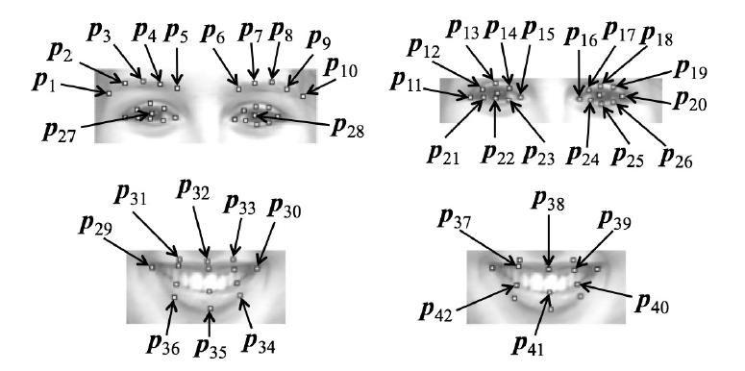

Figure 3.2: Facial feature points [7]

Using these facial feature points the following facial features are calculated.

Gradient of eyebrows (*f1*)

This feature value is based on the gradients al and ar of the two lines obtained from facial feature points on left and right eyebrows using least squares. This feature value is obtained through Equation 3.1.

al - gradient of points p1, p2, p3, p4 and p5

ar - gradient of points p6, p7, p8, p9 and p10

Equation 3.1: Gradient of eyebrows

Distance between eyebrows and eyes ( *f2* )

Using the mean distance between the facial feature points on eyebrows and those on the upper side of eyes, the value of this feature is obtained through Equation 3.2.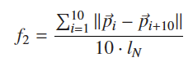

Equation 3.2: Distance between eyebrows and eyes ( *f2* )

Here, lN is a normalisation factor for the difference of the size of a face. It is defined as the distance between the centre points of left and right eyes, that is,

Equation 3.3: Normalisation factor

p27 and p28 being points 27 and 28.

Area between eyebrows ( *f3* )

This feature value is given by Equation 3.4 as the area formed by connecting four facial feature points p5, p6, p16 and p15 located at the inner corners of eyebrows and eyes.

Here, S is the area of a polygon formed by connecting points p5, p6, p16 and p15.

Equation 3.4: Area between eyebrows ( *f3* )

Area of eyes ( *f4* )

By normalising the area of left and right eyes represented by two octagons, this feature value is defined by Equation 3.5.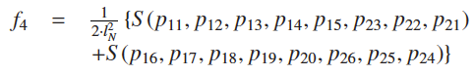

Equation 3.5: Area of eyes ( *f4* )

Vertical to horizontal ratio of eyes ( *f5* )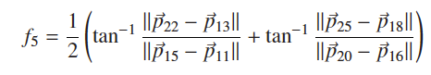

Equation 3.6: Vertical to horizontal ratio of eyes ( *f5* )

Based on the ratio of the distance between top and bottom points to the distance between left and right points on an eye, this feature value is defined by Equation 3.6 .

Area of the circumference of a mouth ( *f6* )

This feature value is defined by Equation 3.7 as the area of an octagon formed by connecting eight facial feature points located on the circumference of a mouth.

Equation 3.7: Area of the circumference of a mouth ( *f6* )

Area of inner circumference of a mouth ( *f7* )

Similar to the sixth feature value, this feature value is defined by Equation 3.8 as the area of an octagon formed by connecting eight facial feature points located on the inner circumference of a mouth.

Equation 3.8: Area of inner circumference of a mouth ( *f7* )



Vertical to horizontal ratio of the circumference of a mouth ( *f8* )

Equation 3.9: Vertical to horizontal ratio of the circumference of a mouth ( *f8* )

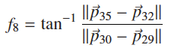

Based on the ratio of the distance between top and bottom points to the distance between left and right points on the circumference of a mouth, this feature value is defined by Equation 3.9 .

Vertical to horizontal ratio of the inner circumference of a mouth ( *f9* )

Equation 3.10: Vertical to horizontal ratio of the inner circumference of a mouth ( *f9* )

Similar to the eighth feature value, this feature value is defined by Equation 3.10 based on the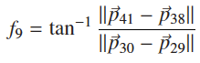 ratio of the distance between top and bottom points to the distance between left and right points on the inner circumference of a mouth.

Vertical position of the corner of a mouth ( *f10* )

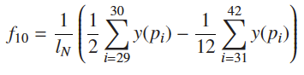

Equation 3.11: Vertical position of the corner of a mouth ( *f10* )

This feature value represents how high the position of the corner of a mouth is. It is defined by Equation 3.11.

Here, y(p) is the y-coordinate of a facial feature point p. If the mean value of the y-coordinate of the facial feature points on the corner of a mouth is larger than that of the other facial feature points on a mouth, *f10* becomes positive. Thus, a larger value of *f10* represents a higher position of the corner of a mouth.

All of the above equations were taken from Nomiya et.al [7] research paper on “Unsupervised Emotional Scene Detection for Lifelog Video Retrieval Based on Gaussian Mixture Model”. Since these are complex mathematical formula, it is quite hard to implement them in high level coding language like Java, therefore Python was used to convert these mathematical formula to computer language. The implementation of the equations (3.1-3.11) in Python are illustrated in APPENDIX 1 of the thesis.

3.3. Machine learning techniques for human emotion identification

There are multiple techniques of training a machine to identify human facial emotions. Shan et.al in their research “Facial expression recognition based on Local Binary Patterns” mentions they have examined different machine learning methods, including template matching, Support Vector Machine (SVM), Linear Discriminant Analysis (LDA) and the linear programming technique, to perform facial expression recognition using Local Binary Patterns features [23]. They have conducted experiments on the Cohn–Kanade database, in which the images have been given a label. “Each image sequence begins with a neutral expression and proceeds to a peak expression. The peak expression for each sequence in fully Facial Action Coding System (FACS) (Ekman, Friesen, & Hager, 2002; Ekman & Friesen, 1979) coded and given an emotion label”[24]. This type of learning is widely known as “Classification”.

Like mentioned above, template matching, SVM, LDA and linear programming techniques, use labeled datasets to train a machine to recognise facial expressions. However, there are other datasets, which isn’t labeled can also be used in training to identify facial emotions. Nomiya et.al [7] uses an unlabelled video dataset, which are Lifelog Videos to recognise facial expressions. They used facial expression recognition using by a clustering algorithm based on Gaussian mixture model using the feature vectors [7].

These techniques are categorised as “unsupervised learning, mostly known as clustering or exploratory data analysis, no labeled data are available” [26]. Similarly the current research also has unlabelled data, therefore unsupervised classification is the best method of classifying emotions of humans.

To do unsupervised classification many different clustering algorithms can be used. Wunsch and Xu [26] have surveyed many of these clustering algorithms. In the conclusion of this survey, they have found out that “There is no clustering algorithm that can be universally used to solve all problems” [26]. The article goes on to discuss that “it is not accurate to say ‘best’ in the context of clustering algorithms” [26]. In this dissertation, given the context of the problem with unlabeled emotions in the video data, I used unsupervised learning method to identify different emotions expressed by users while performing their tasks at work environment. I selected a popular clustering algorithm known as k-means clustering [27] due to its robustness and ease of use as a clustering algorithm in the experiments to group user facial images with similar emotions such as happiness, sadness, and neutral expressions.

Summary

In the chapter the prototype architecture of the system is discussed. Along with it the mathematical formulae that is used to convert facial feature points to meaningful facial features are discussed in length. Thereafter the different machine learning techniques that could be used are discussed in length.

CHAPTER 4: IMPLEMENTATION

In order to implement the methodology mentioned in the previous chapter, it is necessary to evaluate technologies available and analyse which of those are relevant for the project.

4.1. Selection of the coding languages and libraries

There are many computer languages available to implement a design concept. However there are some important factors that should be considered in selection of the most appropriate language to implement the design. Similarly, there are many software libraries that would perform similar functionality. Nevertheless, many of the advanced libraries are licensed as proprietary software while some others are licensed as free and open source and a handful of proprietary libraries give evaluation keys for research purposes.

One of the essential parts in this research is to detect facial feature points from a video feed. There are many proprietary software libraries that could be used for extraction of facial features. Some of those software products are:

EmoVu - Learning based emotion recognition software that could read the emotions of people [14].

Emotient - On demand emotion analysis of videos using facial expression recognition [15].

nViso - 3D Facial Imaging software [16]

Even though the products mentioned above have advanced technologies, it is not possible to use for research purposes since they are proprietary. Therefore to work on this project, a free API should be used. There are only a handful of free API libraries to choose from to recognise facial features.

OpenCV - This open source library provides functionality to do many projects in computer vision [17]. However using this library, the facial feature identification will have to be coded and it doesn’t come as off the shelf functionality. This library is also not very easy to use unlike the other libraries.

flandmark - Open source C library (with interface to MATLAB) implementing a facial landmark detector in static images[18].

There are few proprietary software that gives an evaluation key for research projects. Evaluating several of such software, I chose Luxand face recognition API [8] for detection of facial features.

Luxand face recognition API also known as FaceSDK is a high-performance, multi-platform face recognition, identification and facial feature detection solution [8]. The main reasons why FaceSDK was picked over other software are that,

* 1. They provide an evaluation key for research purposes.
  2. It detects 66 facial features in still pictures and videos.
  3. It is compatible with many different coding languages such as Visual C++, C#, Objective C, VB, Java and Delphi
  4. It is compatible with many operating systems such as Microsoft Windows, MacOS X, Linux, iOS, Android.

Machine learning component of the project is one of the most important components of the project. It is best to use a software package that already exists rather than implementing it from scratch since it is not the major focus of this project. There are many such packages available. Some of the packages considered are:

MATLAB - Proprietary software which has many different components including a component for machine learning. It has many different modules such as classification, regression and clustering [19]. It is a very powerful too, however it is not practical to use this tool as it is proprietary.

GoLearn - GoLearn is a 'batteries included' machine learning library for Go [20]. This does seem to have proper documentation and how to use it therefore even though it is an open source project, it not easy to work with this tool.

The package that works the best for machine learning component of this project is scikit-learn package. There are a number of reasons why scikit-learn machine learning package was chosen over other packages. Firstly, it’s a free software package. Secondly, it has many different modules such as classification, regression, clustering, preprocessing and effective to write scripts using those libraries. Thirdly, the documentation of the software package is extensive, thereby making it easier to work with it. Most importantly scikit-learn is a python machine learning package which is used to implement most of the calculations and machine learning component for this project.

Python is considered as the one of the best languages for crunching, the best bring ‘R’ [9]. Python is also easier to learn than R. Another reason to choose python is that to convert the facial feature points extracted by Luxand API need to be used to calculate facial features. Nomiya et.al has defined the following ten types of facial features using the facial feature points in order to detect discriminative movement of facial feature points in the appearance of various facial expressions [7]. Their paper discusses ten mathematical formulae to calculate different emotion related features. Considering the requirement, Python was considered to be the best coding language for the data preprocessing and machine learning part of the project.

Another coding language needed to be considered to implement Luxand API to extract the facial feature points from images of the videos as Python was not suitable for such tasks. In this section of the project, it focuses on collection of data rather than the actual research, therefore it is necessary to implement it in an effective and efficient manner. Hence, Java was selected as the coding language since it is more familiar to the author.

As the operating system to implement this project, author decided to use Mac OS. The reason for this is because it is the operating system that is readily available and more comfortable to use for the author.

4.2. Collection of videos to create a dataset

There is a multitude of publicly available datasets that could be used for various data mining projects [10] [11]. Since, the specific area that the author is considering in this thesis is very specific to work related stress with webcam footage, it was difficult to find any publicly available datasets. Unfortunately, the one database that is quite inline with what the author is working on, Lifelog videos [7] has been discontinued at the present. Therefore an application had to be implemented in order to gather the necessary webcam feed videos of people working on the computer, to work on the research.

This video capture application is coded using Java and used a generic webcam Java API, ’Webcam capture’ [12]. The application uses the webcam device connected to the computer and it captures video feed of the user. Figure 4.1 shows a screenshot of the video capture application.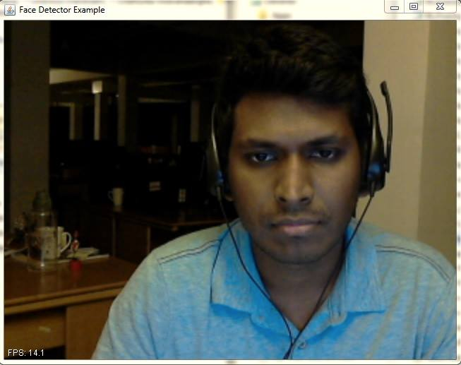

Figure 4.1: Video capture application

Six employees of a major Information Technology (IT) company were given the application to capture the webcam feed during the course of the day. The participants weren’t given any particular instructions, other than how to run the application and how to stop it. Around six hours of video was captured for each participant. The webcam feed was saved in .ts format as it doesn’t take much space in the participant’s computer. This set of videos that were collected online real time were used as the dataset of people working in front of the computer in the experimental section of this thesis.

4.3. Creating a software application to extract feature points

Using the real user dataset collected as mentioned in the previous section, then the facial feature points were gathered. As mentioned earlier, Luxand API was chosen as the library to achieve this.

A software application needed to be coded to run the videos in the dataset, use the Luxand API to gather facial feature points and save it in a format to be used in Python calculations. JavaFX MediaPlayer API was used in creating an application to run the videos in the dataset. However, JavaFX MediaPlayer had a limitation of not being able to play certain formats and .ts format was one of them [21]. Therefore the .ts file format needed to be converted to a format that could be played with JavaFX MediaPlayer. The online site ZamZar [22] was used to convert the .ts format video to .mp4 format for JavaFX MediaPlayer to play them.

Once the videos could be played with JavaFX MediaPlayer API, it was apparent that Luxand API had a limitation too. “Detection of 66 facial features, smooth facial feature tracking in video” [8] wasn’t compatible with Mac OS while it was compatible on Windows OS. Therefore an alternative needed to be found.

The feature of facial features detection for still pictures was compatible with Mac OS, hence to use that feature, using java.awt.Robot functionality, I took a screenshot of every second of the video while it was running. Each of these screenshots is considered as a ‘Frame’ in this thesis. Using these still pictures, the software application was able to find the facial feature points of the participants face and Figure 4.2 is such a screenshot taken by the application.

Figure 4.2: Output image from Luxand API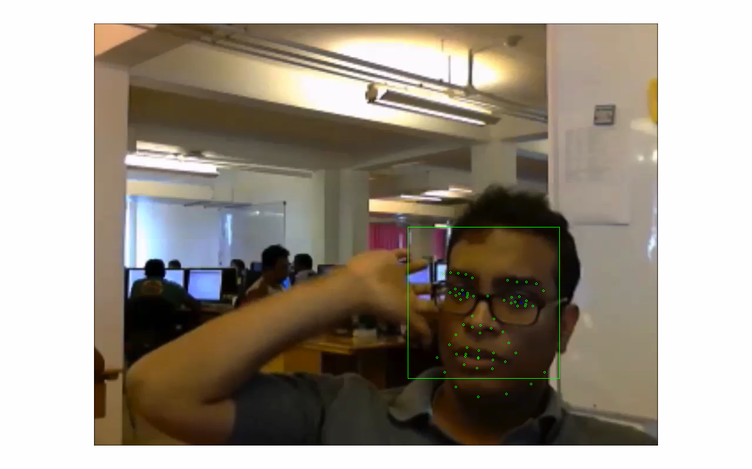

There are frames when the face wasn’t detected by the Luxand API. Figure 4.3 shows such a situation when it fails to capture the face when the user’s face was turned to one side.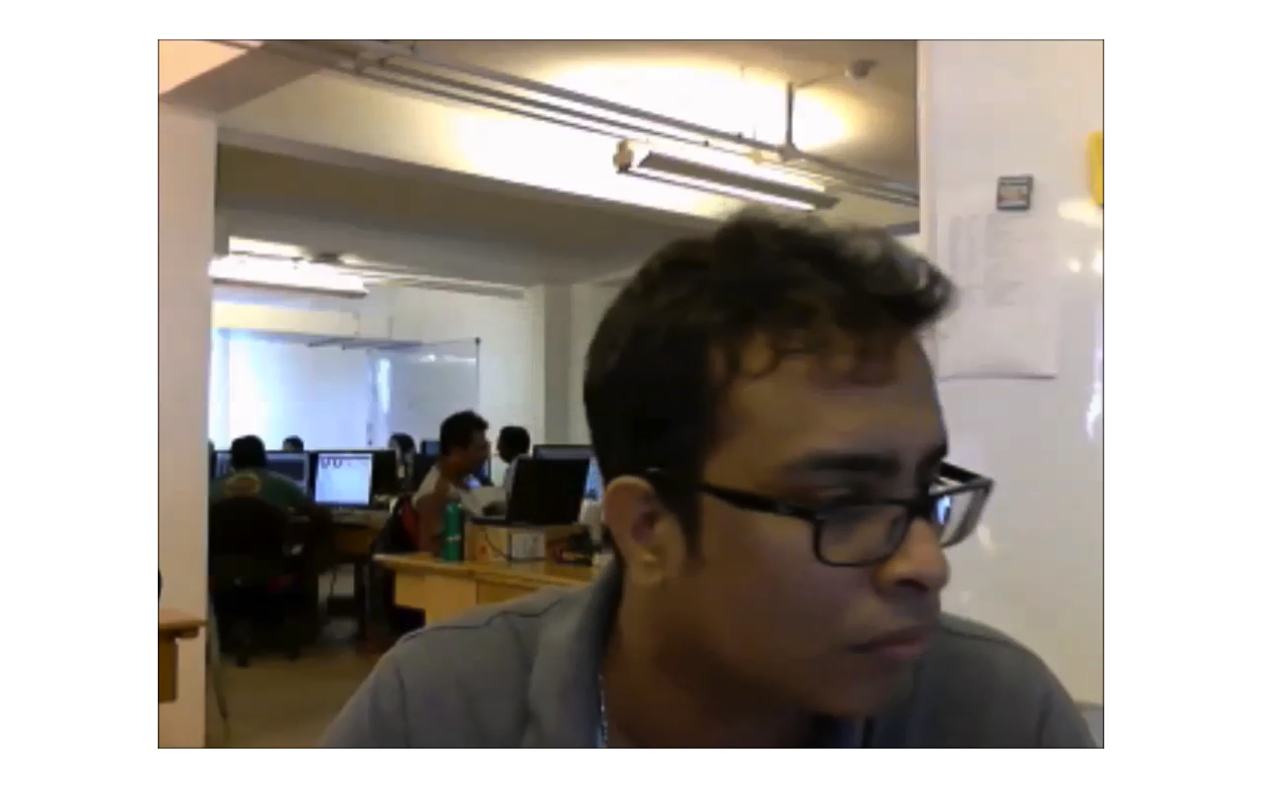

Figure 4.3: Luxand API not detecting the face

The facial feature points of the participant are extracted as Cartesian points from Luxand API. The software application that was created, then writes the coordinates of those points extracted to a .csv file. The sample of the content of the .csv file is shown below.

FrameNumber,FeatureNumber,FeatureXAxis,FeatureYAxis

1,0,715,482

1,1,801,467

1,2,762,520

1,3,732,577

1,4,813,560

1,5,695,588

1,6,861,562

1,7,719,604

‘FrameNumber’ is the frame from which a face was successfully identified and ‘FeatureNumber’ ranges from 0 to 65 one for each detected facial feature point of Luxand API. ‘FeatureXAxis’ and ‘FeatureYAxis’ are the X and Y Cartesian points of the image.

As per the prototype architecture shown in Figure (3.1), once the feature points are extracted, facial feature values need to be calculated. In order to calculate the facial feature values, the ten mathematical formula mentioned as equation 3.1 to 3.11 need to be coded in Python. The code for these mathematical formulae are attached in APPENDIX 1. For each facial feature a Python method has been implemented for the ease of use. The output from these methods are then assigned to a ‘pandas’ data frame.

The python methods that I implemented was cross referenced with “FaceScrub” [31]. A popular, publicly available faces dataset of images. Running the python method through the dataset it was clear that the methods work not only to the dataset that I have gathered but even for a publicly available dataset.

4.4. Pre-processing of facial feature values

Having decided to use k-means algorithm for the unsupervised classification section of the research, there are some pre-processing steps that should be followed in order to make sure that the clustering algorithm performs at its best. In clustering analyses, standardisation may be especially crucial in order to compare similarities between features based on certain distance measures [29]. Standardise, means to bring values of features or attributes from different dynamic range into a specific range [30]. There are different methods of standardisation. Three such standardisation methods are Z-score analysis, Decimal scaling analysis and Min-max analysis. In “Standardization and Its Effects on K-Means Clustering Algorithm” [30] all three of them have been analysed, and as its conclusion, they have mentioned that Z-score as “the most powerful method that will give more accurate and efficient result among the three methods in K-means clustering algorithm” [30].

In my implementation, I tried out two of the above-mentioned, Z-score analysis and Min-max analysis standardisation methods as they are implemented in sklearn package. The results of the k-means clustering differed only by a small margin when the two different standardisations were applied, which would be discussed further in the next chapter.

One of the common problems in machine learning is over-fitting of data. This is when the model or the algorithm fits the data too well [31]. To take measures to check if the data does not over-fit, the data used for this research was split in to two parts. 75 percent of the data is used for training of K-means model while 25 percent of the data are used for testing purposes. Through sklearn package data could be easily split into two such parts.

X_train, X_test = train_test_split(df1_normalize, test_size=0.25, random_state=42)

The code snippet below shows the code line in which the splitting of the data happens. df1_normalize variable holds the data which has been standardised by Z-score analysis. test_size argument defines the percentage of data to be split as the test data sample. random_state is a generator in order to initialise the centres. After the splitting of the data X_train will hold 75 percent of data from df1_normalize, while the rest of the data will be stored in X_test variable.

4.5. Training K-means clustering model

The ‘sklearn’ package has easy implementation of training a model through K-means clustering algorithm. To train the K-means model, the training data (X_train) was used. The below code snippet shows the training of the K-means.

trained_model = KMeans(n_clusters=2,n_init=10,max_iter=750).fit(X_train)

From the parameter n_clusters the number of clusters the data to be grouped is defined, while n_init is the number of times the k-means algorithm will be run with different centroid seeds. max_iter parameter gives the maximum number of iterations of the k-means algorithm for a single run.

To find the best fit for the K-means model, the numbers of the above three parameters were changed and evaluated. The videos in the dataset are recorded in real-life scenario and doesn’t include many different emotions, therefore it was best to train the K-means model for 2 clusters, as then it would have better chance of classifying the data into frames with happy emotions and frames with neutral faces. Therefore the parameter n_clusters was assigned as 2.

Given that the number of data points that is available in the dataset was small, having the K-means model run with many different centroid seeds isn’t ideal. Therefore n_init parameter was initialised as 10.

The parameter max_iter was tuned the most. The default number of max iterations is 300 however, even with 500 max iterations the results varied with each run of K-means. Therefore, after many deliberations the max number of iterations was assigned to 750.

Summary

The justification of choosing different technologies and libraries are discussed at the beginning of this chapter. A detailed account of the data collection software that was built to collect user data and the software to extract facial features is mentioned thereafter. The details of the system of also mentioned in this chapter with accounts of using different pre-processing techniques in order to get better results are mentioned.

Unsupervised learning technique of K-means was used to group faces of similar features, thereby being able to differentiate from happy emotion and neutral and other emotions was able to achieve during the implementation of the system.

CHAPTER 5: EVALUATION & RESULTS

This chapter focuses on illustrating the results of the implementation chapter and evaluating the final product.

5.1. Discussion on the feedback from users participated for data collection

After the user participated for the data collection, a small feedback form was handed out to get more information about how their work was during the day. Figure 5.1 shows the questions that was asked from the user.

Feedback form

1. How many hours of work did you do for today?
2. How long did you take to have lunch?
3. How many breaks did you have in between work (excluding lunch break)?
4. Do you feel that you had a productive day of work?
5. Are there any deadlines that need to be addressing in the near future?

Figure 5.1: Feedback form questions

Questions 1 - 3 are directed to gather information about the time they worked for the day. This gives an indication for how long the user has to work for a day. Question 4 is directed to gather knowledge about the mental state of the user at the end of the day and Question 5 is to know if the user is under duress of a deadline.

The feedback given by the user helps to confirm the findings from the system. All information of the feedback forms received are attached in APPENDIX 2.

5.2. Discussion on the results of K-means clustering

| **Frames in video** | **Frames with identified face** | **K-means clustering training data (75% of 2333)** | | **K-means clustering testing data (25% of 2333)** | |
| --- | --- | --- | --- | --- | --- |
| Label 0 | Label 1 | Label 0 | Label 1 |
| 3590 | 2333 | 650 | 1099 | 231 | 353 |

Table 5.1: Frame count at each stage

Table 5.1 shows the number of frames for each of the stages of the system. According to Figure 3.1 the first phase of the system is to play a video from the dataset and save frames as still pictures. The number of frames captured by the system for the training video was 3590 frames. These frames must then be parsed by the Luxand API to gather information about the facial feature points of each of the frame. As mentioned in Figure 4.2 and Figure 4.3 there are some still picture which were not able to detect a face. The number of frames that were able to detect a face was 2333 frames. That’s a 65% face detection rate from Luxand API.

As shown in Figure 3.1, the next phase of the system is to calculate facial features from the still pictures where a face was detected. As mentioned in heading 4.4 (Pre-processing of facial feature values) the data was split to two parts. 1749 frame (75% of 2333) were used the train K-means clustering model, while the rest (584 frames) was kept for testing purposes. Having the K-means clustering model to group in to two clusters each frame would be labeled either 0 or 1. When running the training data, 650 frames were labeled as 0 while the rest of 1099 frames were labeled 1.

Even though frames are labeled, it is still to be found out if K-means have grouped similar emotions to the same cluster. Going through the output still frames, there are frames which we could clearly identify as faces which has a smile which portrait happy emotion. Identifying such images and back tracking to see if it is classified in to the same label is one way of checking if K-means has clustered frames of similar emotions.

Figure 5.2: Image which shows happy emotion (Frame #994)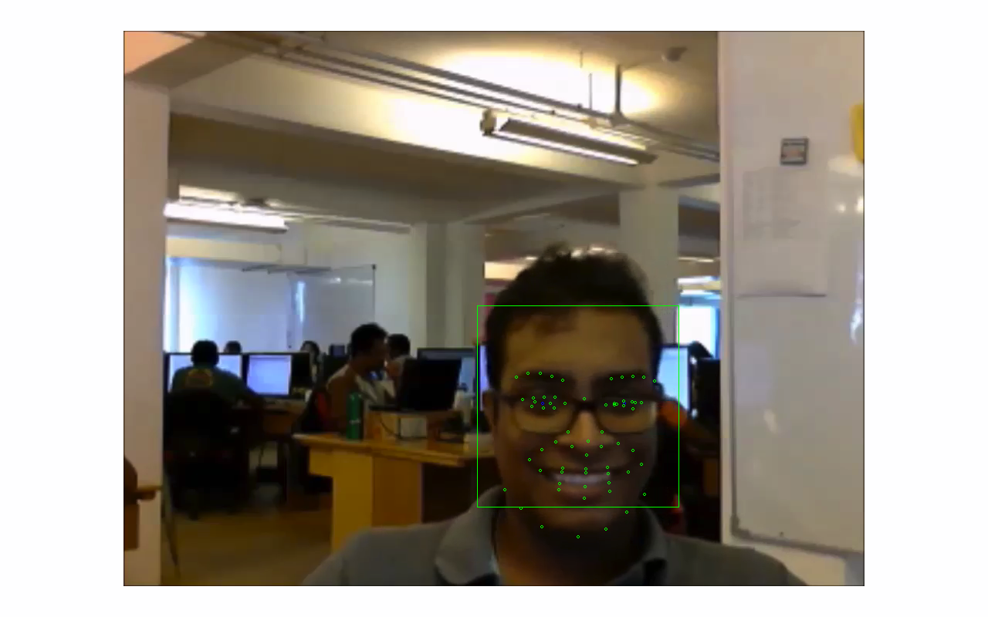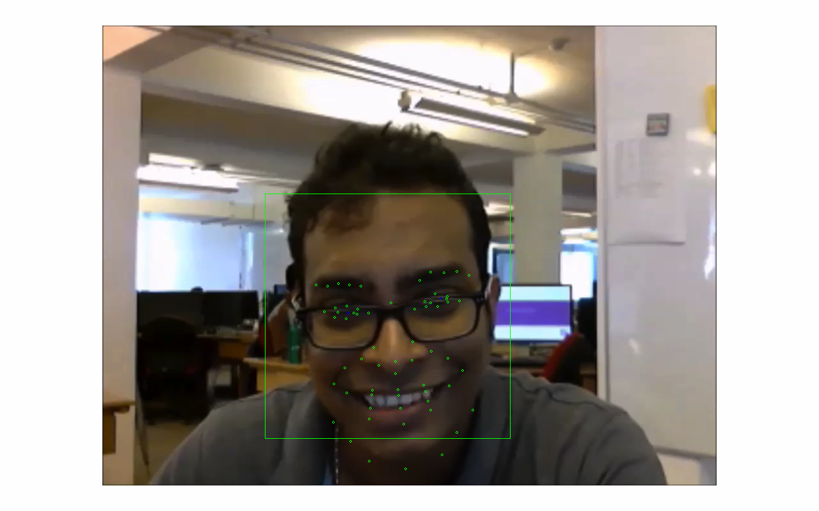

Figure 5.3: Another image which shows a happy emotion (Frame #99)

The frames shown above appear in different places in the video. Both clearly portrait a happy emotion. Figure 5.2 appears in frame number 994 while Figure 5.3 appear in frame number 99. Looking at the output result of the k-means output, both of the frames have been given the same label (label 0). The above frames can be found in the training data. Therefore there is a possibility that K-means have over-fit for the given data.

Therefore it is necessary to cross check with the test data that was not used for K-means clustering model training.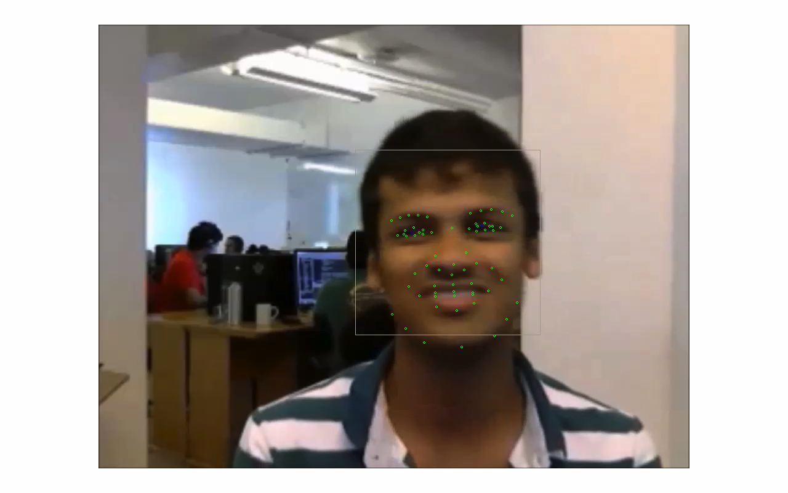

Figure 5.4: Happy emotion in test data (Frame #2515)

Figure 5.5: Happy emotion in test data (Frame #2121)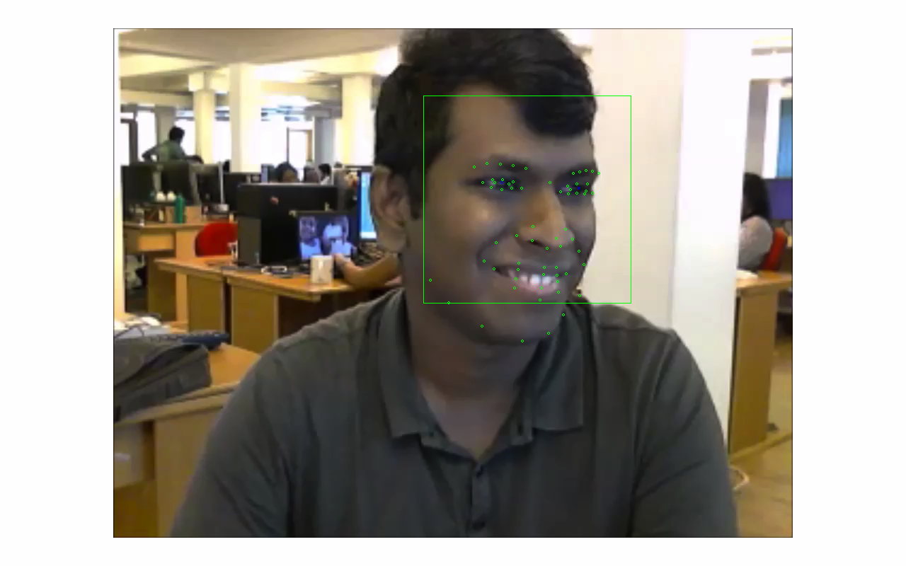

Both Figure 5.4 and 5.5 could be found in the test data. Both clearly indicate a happy emotion. Looking at the output result for the test data, both the frames are labeled the same (label 0). Therefore K-means clustering has been successful in giving the same label for happy faces.

The video frames also comprise of neutral emotions. It is necessary to see if the neutral emotions are also clustered together. Looking how the test data are clustered is the best as there is little change of data being overfitted.

Figure 5.6 : Face with a neutral emotion in test data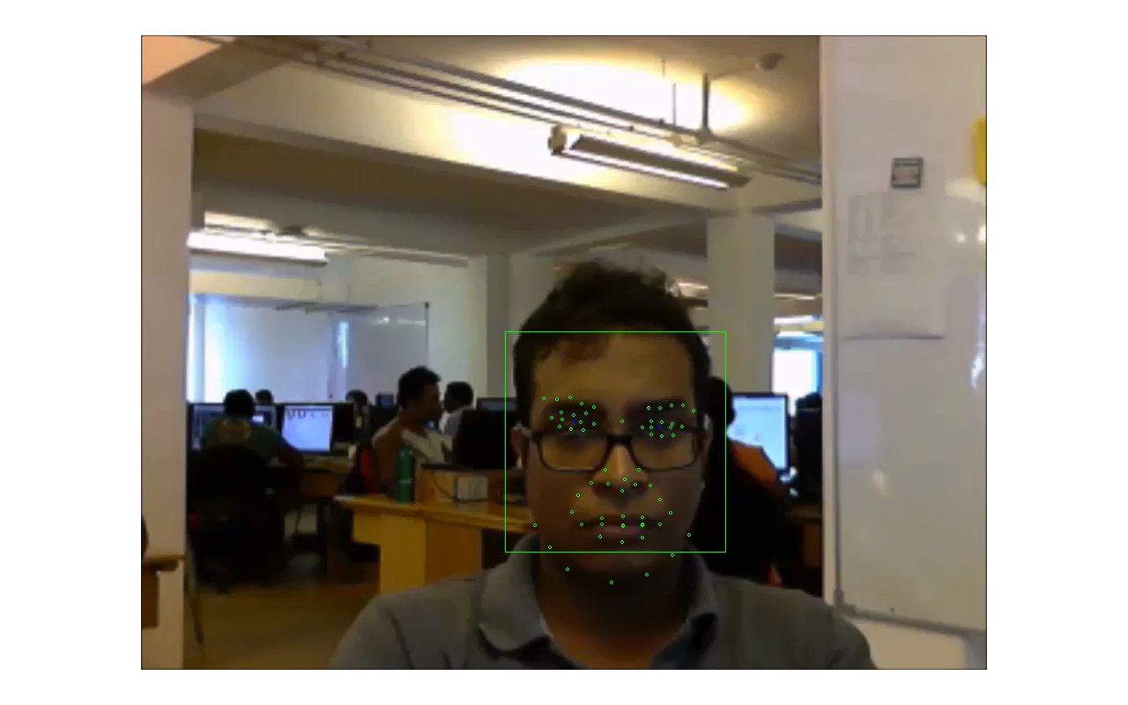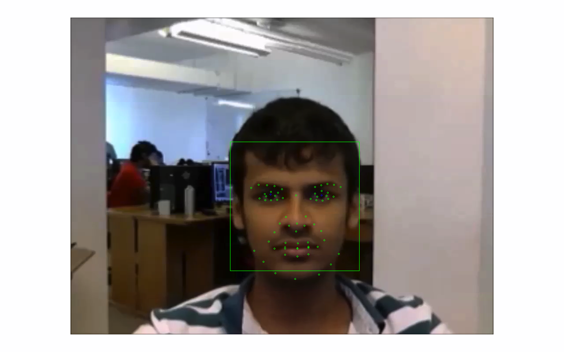

Figure 5.7: Face with a neutral emotion in test data

Figure 5.6 and 5.7 illustrate frames which has captured neutral emotion of a user. K-means clustering model has given the same label (label 1) for both of these frames which is a different label from the happy emotion mentioned above, therefore it has categorised neutral emotions correctly.

The video frames which have a happy emotion are grouped together in the K-means clustering model as are label 0 frames while the neutral emotion frames are of label 1.

5.2. Results of different pre-processing methods

In chapter 4.4, different pre-processing methods were discussed. During the implementation stage the author tried out two different pre-processing techniques and the effects it would have on the final result.

Min-Max Analysis

The table below illustrate the number of frames labelled 0 and 1 when using Min-Max Analysis as the data standardisation method.

| **K-means clustering training data (75% of 2333)** | | **K-means clustering testing data (25% of 2333)** | |
| --- | --- | --- | --- |
| Label 0 | Label 1 | Label 0 | Label 1 |
| 651 | 1098 | 232 | 352 |

Table 5.2 : K-means clustering labelling of video frames using Min-Max Analysis

Z-Score Analysis

| **K-means clustering training data (75% of 2333 frames)** | | **K-means clustering testing data (25% of 2333 frames)** | |
| --- | --- | --- | --- |
| Label 0 | Label 1 | Label 0 | Label 1 |
| 650 | 1099 | 231 | 353 |

Table 5.3: K-means clustering labelling of video frames using Z-Score Analysis

As seen by the two tables there isn’t any difference in the K-means clustering results because of using different pre-processing methods.

Summary

How similar features are labeled with the same tag, with illustrations of different frames was discussed during this chapter. Results of the classification are discussed with tables.

CHAPTER 6: CONCLUSION & FUTURE WORK

In this chapter discusses about the results of the research and give an insight about the future work that could derive from this initial work.

6.1. Retrospect on the aims and objectives

User stress detection is a path where computer science could explore more, more so with non-invasive technologies. In retrospect the aims and objectives that was set out to do at the start of this research was able to achieve.

Using a non-invasive technology such as webcam in finding indications of stress of users was able to achieve during this research. A thorough literature review was conducted at the start of the research, gaining a lot of knowledge in this research topic.

Different processes such as Min-Max Analysis and Zero score analysis was performed to achieve better results of the final classification of emotions.

6.2. Conclusion derived from the results

It was found that there was a clear distinguishable difference of emotions of the video frames which was classified with label 0 and 1. Label 0 showed more of happy emotions while label 1 showed neutral and other facial emotions.

Over-fitting of data was reduced by splitting of data into two parts of training data and test data. Using the test data using the modelled trained by training data it was found out of 584 frames only 231 of them are labeled 0. Therefore the percentage of frames with happy emotions are roughly 39% of the total frames.

With having emotions such as neutral, anger, frustration, disgust, sad, surprised be classified in to label 1, classification of 39% of happy faces is quite a large number and therefore these users doesn’t seems to have an indication of stress.

This result is quite positive in the advancement of detecting stress using non-invasive methods and author believes it could be improved for better results with further work.

6.3. Future work

With the rapid advancement of technology, there are new devices that could be used as non-invasive methods of gathering physiological data. GSR and HRV are two of the most precise measurements that could be used for detecting stress.

With the invention of new devices such as smart watches and other wearable devices, it is now possible to monitor the heart rate in non-invasive manner. Therefore taking use of the new devices more precise physiological data could be gathered and thereby better detection of stress of the user could be achieved.

The dataset for this work was quite limited as the author had to recored videos and building a dataset. However if there was publicly available dataset with more variety and number of videos this project could have yielded better results, and classified many more subtle humans emotions such as sadness, frustration, anger, which could indicate better the stress level of the user.

REFERENCES

[1] K. Sullivan, 'Deadlines, stress cause leaders to make poor choices', FierceHealthcare, 2015. [Online]. Available: http://www.fiercehealthcare.com/story/neuroimaging-breaks-down-executive-leadership-decision-making/2014-04-29. [Accessed: 07- Dec- 2015].

[2] Helpguide.org, 'Stress Symptoms, Signs, & Causes - Helpguide.org', 2015. [Online]. Available: http://www.helpguide.org/articles/stress/stress-symptoms-causes-and-effects.htm. [Accessed: 31- Oct- 2015].

[3] msnbc.com, 'Can stress actually be good for you?', 2006. [Online]. Available: http://www.nbcnews.com/id/15818153/ns/health-mental_health/t/can-stress-actually-be-good-you/#.VjQqI64rKDU. [Accessed: 31- Oct- 2015].

[4] Jing Zhai and Armando Barreto, “Stress Recognition Using Non-invasive Technology”, Electrical and Computer Engineering Department, Biomedical Engineering Department Florida International University.

[5] Suranga D.W. Gunawardhane, Pasan M. De Silva, Dayan S.B. Kulathunga, Shiromi M.K.D. Arunatileka, “Non invasive human stress detection using key stroke dynamics and pattern variations”, University of Colombo School of Computing .

[6] Michael Sung and Alex (Sandy) Pentland, “PokerMetrics: Stress and Lie Detection through Non-Invasive Physiological Sensing”, MIT Media Laboratory, Human Dynamics Group.

[7] Hiroki Nomiya, Atsushi Morikuni and Teruhisa Hochin, “Unsupervised Emotional Scene Detection for Lifelog Video Retrieval Based on Gaussian Mixture Model” in 17th International Conference in Knowledge Based and Intelligent Information and Engineering Systems, 2003, pp. 375 – 384

Luxand FaceSDK. Luxand, Inc., 2015.

[8] A. Nicolaou and A. Nicolaou, 'The 9 Best Languages For Crunching Data', Fast Company, 2014. [Online]. Available: http://www.fastcompany.com/3030716/the-9-best-languages-for-crunching-data. [Accessed: 02- Nov- 2015].

[9] Archive.ics.uci.edu, 'UCI Machine Learning Repository', 2015. [Online]. Available: http://archive.ics.uci.edu/ml/. [Accessed: 02- Nov- 2015].

[10] Inf.ed.ac.uk, 'Datasets for Data Mining', 2015. [Online]. Available: http://www.inf.ed.ac.uk/teaching/courses/dme/html/datasets0405.html. [Accessed: 02- Nov- 2015].

[11] Webcam-capture.sarxos.pl, 'Webcam Capture in Java', 2015. [Online]. Available: http://webcam-capture.sarxos.pl/. [Accessed: 02- Nov- 2015].

[12] F. Sun, C. Kuo, H. Cheng, S. Buthpitiya, P. Collins and M. Griss, 'Activity-aware Mental Stress Detection Using Physiological Sensors', Carnegie Mellon University, 2010.

[13] EmoVu, 'EmoVu emotion recognition software', 2015. [Online]. Available: http://emovu.com/e/. [Accessed: 11- Dec- 2015].

[14] Emotient, 'Emotient Analytics - Emotient', 2015. [Online]. Available: http://www.emotient.com/products/emotient-analytics/. [Accessed: 11- Dec- 2015].

[15] Nviso.ch, '3D Facial Imaging Software and Emotion Analytics Cloud Service | nViso', 2015. [Online]. Available: http://www.nviso.ch/. [Accessed: 11- Dec- 2015].

[16] Opencv.org, 'OpenCV | OpenCV', 2015. [Online]. Available: http://opencv.org/. [Accessed: 12- Dec- 2015].

[17] Cmp.felk.cvut.cz, 'flandmark - open-source implementation of facial landmark detector', 2015. [Online]. Available: http://cmp.felk.cvut.cz/~uricamic/flandmark/. [Accessed: 12- Dec- 2015].

[18] In.mathworks.com, 'Machine Learning with MATLAB', 2015. [Online]. Available: http://in.mathworks.com/solutions/machine-learning/?requestedDomain=www.mathworks.com. [Accessed: 13- Dec- 2015].

[19] GitHub, 'sjwhitworth/golearn', 2015. [Online]. Available: https://github.com/sjwhitworth/golearn. [Accessed: 13- Dec- 2015].

[20] Docs.oracle.com, "javafx.scene.media (JavaFX 2.2)", 2015. [Online]. Available: https://docs.oracle.com/javafx/2/api/javafx/scene/media/package-summary.html. [Accessed: 20- Dec- 2015].

[21] Zamzar.com, "Zamzar - video converter, audio converter, image converter, eBook converter", 2015. [Online]. Available: http://www.zamzar.com/. [Accessed: 20- Dec- 2015].

[22] C. Shan, S. Gong and P. McOwan, "Facial expression recognition based on Local Binary Patterns: A comprehensive study", Image and Vision Computing, vol. 27, no. 6, pp. 803-816, 2009.

[23] Pitt.edu, "The Affect Analysis Group at Pittsburgh", 2015. [Online]. Available: http://www.pitt.edu/~emotion/ck-spread.htm. [Accessed: 23- Dec- 2015].

[24] M. Weber, "Unsupervised Learning of Models for Object Recognition", Doctor of Philosophy, California Institute of Technology Pasadena, California, 2000.

[25] Scholarsmine.mst.edu, "Survey of clustering algorithms", 2005. [Online]. Available: http://scholarsmine.mst.edu/cgi/viewcontent.cgi?article=2429&context=faculty_work. [Accessed: 24- Dec- 2015].

[26] A. Jain, "Data clustering: 50 years beyond K-means", Pattern Recognition Letters, vol. 31, no. 8, pp. 651-666, 2010.

[27] Alberto De Santos, Carmen Sánchez-Avila, Javier Guerra-Casanova and Gonzalo Bailador-Del Pozo (2011).Real-Time Stress Detection by Means of Physiological Signals, Recent Application in Biometrics, Dr. Jucheng Yang (Ed.), ISBN: 978-953-307-488-7, InTech, Available from: <http://www.intechopen.com/books/recentapplication-in-biometrics/hand-biometrics-in-mobile-devices>

[28] Sebastianraschka.com, "Feature Scaling", 2015. [Online]. Available: http://sebastianraschka.com/Articles/2014_about_feature_scaling.html#z-score-standardization-or-min-max-scaling. [Accessed: 28- Dec- 2015].

[29] I. Bin Mohamad and D. Usman, "Standardization and Its Effects on K-Means Clustering Algorithm", Research Journal of Applied Sciences, Engineering and Technology, vol. 6, no. 7, pp. 3299-3303, 2013.

[30] E. Statistician, "Machine Learning Lesson of the Day – Overfitting and Underfitting | StatsBlogs.com | All About Statistics", Statsblogs.com, 2014. [Online]. Available: http://www.statsblogs.com/2014/03/20/machine-learning-lesson-of-the-day-overfitting-and-underfitting/. [Accessed: 28- Dec- 2015].

[31] S. Winkler, "vintage - resources", Vintage.winklerbros.net, 2015. [Online]. Available: http://vintage.winklerbros.net/facescrub.html. [Accessed: 30- Dec- 2015].

APPENDIX 1 : Facial feature calculation mathematical formula in python

1.1. Implementation of the mathematical formulae

def leastSq(x,y): # Method to calculate the least square of points

A = np.vstack([x, np.ones(len(x))]).T

m, c = np.linalg.lstsq(A, y)[0]

return m

def gradEyes(x,y,x1,y1): # Gradient of eyebrows

leftEye = leastSq(x,y)

rightEye = leastSq(x1,y1)

return (leftEye-rightEye)/2

def normalizeFactor(point27, point28): #Facial normalisation factor calculate

norFac = scsp.distance.cdist(point27, point28, 'euclidean') # The euclidean distance between right eye and left eye

return norFac

def distEyesEyebrows(points, lN): #Distance between the eyes and the eyebrows

totalEucDis = 0

for i in range(len(points)-10):

eucDis = scsp.distance.cdist(points[i], points[i+10], 'euclidean')

totalEucDis += eucDis

distEyes = totalEucDis/(10*lN)

return distEyes

def areaOfTriangle(point1, point2, point3): # Calculate area of a triangle to calculate the area of a polygon

area = abs((point1[0][0]*(point2[0][1]-point3[0][1]) + point2[0][0]*(point3[0][1]-point1[0][1]) + point3[0][0]*(point1[0][1]-point2[0][1])) / 2)

return area

def areaBetweenEyes(point5, point6, point16, point15, lN): # Calculate area of a 4 point polygon

tri1 = areaOfTriangle(point5,point6,point16)

tri2 = areaOfTriangle(point5,point16,point15)

areaEyes = (tri1 + tri2)/ lN**2

return areaEyes

def areaofOctogon(point1,point2,point3,point4,point5,point6,point7,point8): # Calculate area of a octogon with triangles

tri1 = areaOfTriangle(point1,point2,point3)

tri2 = areaOfTriangle(point1,point3,point4)

tri3 = areaOfTriangle(point1,point4,point5)

tri4 = areaOfTriangle(point1,point5,point6)

tri5 = areaOfTriangle(point1,point6,point7)

tri6 = areaOfTriangle(point1,point7,point8)

area = tri1 + tri2 + tri3 + tri4 + tri5 + tri6

return area

def areaOfEyes(point11,point12,point13,point14,point15,point23,point22,point21,point16,point17,point18,point19,point20,point26,point25,point24,lN): #area of eyes using area of octogon

areaLeftEye = areaofOctogon(point11,point12,point13,point14,point15,point23,point22,point21)

areaRightEye = areaofOctogon(point16,point17,point18,point19,point20,point26,point25,point24)

areaEyesBoth = (areaLeftEye + areaRightEye) * (1/lN**2)

return areaEyesBoth

def vTHRofEyes(point22,point13,point15,point11,point25,point18,point20,point16): # vertical of horizontal ratio of eyes

distance1 = scsp.distance.cdist(point22, point13, 'euclidean')

distance2 = scsp.distance.cdist(point15, point11, 'euclidean')

distance3 = scsp.distance.cdist(point25, point18, 'euclidean')

distance4 = scsp.distance.cdist(point20, point16, 'euclidean')

arctan1 = np.arctan(distance1/distance2)

arctan2 = np.arctan(distance3/distance4)

feature5 = 0.5 * (arctan1 + arctan2)

# print feature5

return feature5

def areaCircumOfMouth(point1,point2,point3,point4,point5,point6,point7,point8,lN): # Area of the circumference of a mouth

area = areaofOctogon(point1,point2,point3,point4,point5,point6,point7,point8)

feature6 = area / lN**2

return feature6

def vTHRofCircMouth(p1,p2,p3,p4): #Vertical to horizontal ratio of the circumference of a mouth

distance1 = scsp.distance.cdist(p1, p2, 'euclidean')

distance2 = scsp.distance.cdist(p3, p4, 'euclidean')

f8 = np.arctan(distance1/distance2)

return f8

def vposOfMouth(p29,p30,p31,p32,p33,p34,p35,p36,p37,p38,p39,p40,p41,p42,lN): #Vertical position of the corner of a mouth

a1 = np.array([p29[0][1],p30[0][1]])

a2 = np.array([p31[0][1],p32[0][1],p33[0][1],p34[0][1],p35[0][1],p36[0][1],p37[0][1],p38[0][1],p39[0][1],p40[0][1],p41[0][1],p42[0][1]])

f10 = (1/lN) * (np.mean(a1)-np.mean(a2))

return f10

1.2. Calculate the value for each feature

feature1 = gradEyes(x,y,x1,y1) # Calculate Gradient of eyebrows

feature2 = distEyesEyebrows(points1to20, lN) # Calculate Distance between eyebrows and eyes

feature3 = areaBetweenEyes(point5,point6,point15,point16,lN) # Area between eyebrows

feature4 = areaOfEyes(point11,point12,point13,point14,point15,point23,point22,point21,point16,point17,point18,point19,point20,point26,point25,point24,lN) # Calculate Area of eyes

feature5 = vTHRofEyes(point22,point13,point15,point11,point25,point18,point20,point16) #Calculate Vertical to horizontal ratio of eyes

feature6 = areaCircumOfMouth(point29,point31,point32,point33,point30,point34,point35,point36,lN) # Calculate Area of the circumference of a mouth

feature7 = areaCircumOfMouth(point29,point37,point38,point39,point30,point40,point41,point42,lN) #Calculate Area of inner circumference of a mouth

feature8 = vTHRofCircMouth(point35,point32,point30,point29) #Vertical to horizontal ratio of the circumference of a mouth

feature9 = vTHRofCircMouth(point41,point38,point30,point29) #Vertical to horizontal ratio of the inner circumference of a mouth

feature10 = vposOfMouth(point29,point30,point31,point32,point33,point34,point35,point36,point37,point38,point39,point40,point41,point42,lN) #Vertical position of the corner of a mouth

APPENDIX 2 : Feedback forms

Participant 1

1. How many hours of work did you do for today? 8
2. How long did you take to have lunch? 1/2 hour
3. How many breaks did you have in between work (excluding lunch break)? 1
4. Do you feel that you had a productive day of work? yes
5. Are there any deadlines that need to be addressing in the near future? End of this week

Participant 2

1. How many hours of work did you do for today? 9
2. How long did you take to have lunch? 1/2 hour
3. How many breaks did you have in between work (excluding lunch break)? 1
4. Do you feel that you had a productive day of work? yes
5. Are there any deadlines that need to be addressing in the near future? End of this week

Participant 3

1. How many hours of work did you do for today? 8
2. How long did you take to have lunch? 1 hour
3. How many breaks did you have in between work (excluding lunch break)? 2
4. Do you feel that you had a productive day of work? yes
5. Are there any deadlines that need to be addressing in the near future? End of next week

Participant 4

1. How many hours of work did you do for today? 8
2. How long did you take to have lunch? 1 hour
3. How many breaks did you have in between work (excluding lunch break)? 1
4. Do you feel that you had a productive day of work? yes
5. Are there any deadlines that need to be addressing in the near future? End of the week

Participant 5

1. How many hours of work did you do for today? 8
2. How long did you take to have lunch? 1/2 hour
3. How many breaks did you have in between work (excluding lunch break)? 2
4. Do you feel that you had a productive day of work? yes
5. Are there any deadlines that need to be addressing in the near future? End of next week

Participant 6

1. How many hours of work did you do for today? 8
2. How long did you take to have lunch? 1 hour
3. How many breaks did you have in between work (excluding lunch break)? 2
4. Do you feel that you had a productive day of work? yes
5. Are there any deadlines that need to be addressing in the near future? end of next week